Alphabets @ Cofton Pre-School - Newsletter September 2021

Welcome
Firstly we would like to welcome you all back following the Summer holidays. We would like to say big welcome to all our new children we are looking forward to getting to know you and exploring and learn together.

This term we will be doing lots of fun and exciting activities based upon each child’s likes and interests, we encourage the children to be curious and self-initiate activities with the support of the key workers (the key worker will be allocated to each child within the next few weeks, to allow for settling in). Along the way we will be learning about each other in our all about me topic.

Your child’s progress through the Early Years Foundation Stage is being documented by the key person on the learning and development sheets. Your child’s key person will update you along the way on your child’s achievements and advise you on what they are working on next.

Illness
The lastest guidance from the NHS regarding COVID – 19 are as follows. The main symptoms of coronavirus (COVID-19) are:

a high temperature – this means you feel hot to touch on your chest or back (you do not need to measure your temperature)

a new, continuous cough – this means coughing a lot for more than an hour, or 3 or more coughing episodes in 24 hours (if you usually have a cough, it may be worse than usual)

a loss or change to your sense of smell or taste – this means you've noticed you cannot smell or taste anything, or things smell or taste different to normal

What to do if you have symptoms
If you or your child has any of the main symptoms of COVID-19, even if they're mild, you should:

- Get a PCR test (test that is sent to a lab) to check if they have COVID-19 as soon as possible.
- Stay at home and do not have visitors (self-isolate) until you get your test result – only leave your home to have a test.

Call 111 if you're worried about a baby or child under 5. If your child seems very unwell, is getting worse or you think there's something seriously wrong, call 999. Do not delay getting help if you're worried.
Just a reminder to all parents if your child is poorly or going to be off for any reason please do call in to let us know. Our telephone number is 0121 477 6279.

Should you need to you can arrange for a Covid19 test at https://www.gov.uk/guidance/coronavirus-covid-19-getting-tested

If the outcome of the Covid test is negative the self isolation period ends and your child can then return to Pre-School.

If your child develops Symptoms of Covid19 whilst at Pre-School
If your child develops symptoms of Covid19 whilst with us during the day, we will need to move them in to our Isolation room immediately. A member of staff will accompany them in full Personal Protective Equipment, you will be contacted and expected to collect your child immediately and arrange for your child to be tested.

Weather
As the weather is a little unpredictable at the moment please can you provide your child with named wellies and coat so that we are able to go outside in all weathers.

Due to Covid-19 our guidance states that we have to have the rooms well ventilated so we are having to keep the windows open in all weathers. Therefore sometimes the children are saying that they are a little cold whilst we are playing inside. Please can we ask you to provide your child with a jumper, cardigan, hoody or long sleeved top.

Admissions for ‘Big’ School
If your child is due to go to school in September 2022 you need to apply for your child’s place online soon, admissions open on 1st October 2021.

Even if you have older children at the school you still need to apply and don’t forget applying online as soon as you can, this may give you more chance of getting your first choice of school.

You can apply at:
https://www.birmingham.gov.uk/info/20119/school_admissions/1786/apply_for_reception_primary_school
Parents can apply for a place in the Autumn of the year before their child turns 4 years of age. It is important that you apply for a place as soon as possible:
- attendance at a nursery class does not give a child automatic priority for a place
- do not wait until your child is five years old, or your preferred school may already be full
Lunchboxes
Please can we ask parents to chop grapes in half lengthways, and also cut cherry tomatoes in half to avoid the possibility of them choking. We must also ask that you don’t send sweets in lunchboxes.

Road Restrictions
Just to make you all aware that there are restrictions on Wootton Road (outside of Alphabets & Cofton School) These restrictions state that cars cannot park or drive up the road between the hours of 8.15 -9.15am and 2.45pm – 3.45pm.
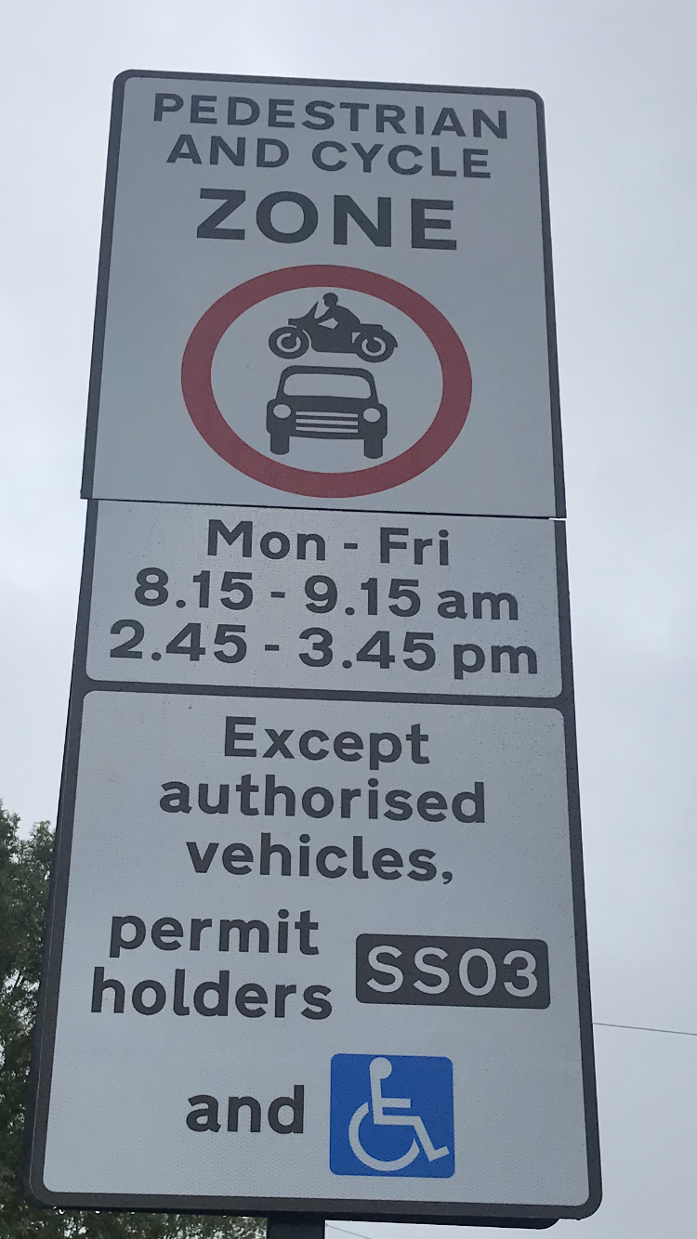

Contact Information
Please can you let us know if your address or telephone numbers change at all is it important for us to keep them up to date for emergency purposes.

Alphabets @ Cofton Pre-School - Important Dates

Thursday 21st October 2021 – Pre-School Halloween Party
(If children would like to dress up on this day they are very welcome to, we will be doing fun games and activities)

Staff Training Day - Friday 22nd October 2021 (Pre-School Closed)

Half Term - 25th – 30th October 2021 (Pre-School Closed)

Children In Need Day – Dress up for a donation – Friday 19th November 2021

Christmas Jumper Day – Wear a Christmas Jumper for a donation – Friday 10thDecember 2021

Thursday 16th December 2021 – Pre-School Party Day
(Pre-School Breaks Up for Christmas, last day of term)

Staff Training Day - Friday 17th December 2021

Pre-School reopens to children after Christmas on Tuesday 4th January 2022

We would like to thank you all for your continual support
Many thanks from the Alphabets staff
Telephone Number: 0121 477 6279, Email Address: alphabets.at.cofton@gmail.com

Website Address: www.longbridgechildcare.org.uk

